Group 18

Author: 王龙川

Software Requirements

Elevator

Table of Contents

System Objective 2

Domain Analysis 2

System Architecture 5

Use Cases 6

Software Requirements 6

R1: Elvator Car 6

R2: Button Panel 7

R3: Display 7

R4: Weight Slider 7

## System Objective

In this project, we are developing a software that can simulate an elevator system.

## Domain Analysis

The elevator system coordinates two elevators in a building with three floors.

There is a button panel on each floor. The button panel on the first floor only has one button for moving up. The button panel on the second floor has two buttons for moving up and down separately. The button panel on the third floor has only one button for moving down.

There are three button panels in each elevator. One with three buttons with number 1,2,3 to tell the elevator which floor to move to. The other with two buttons to tell the elevator to open or close the door. The third with one button called ‘Help’. If this button is pressed, elevator stops and calls for help. A message box will pop up.

There is a display on each floor and in each elevator to show whether the elevator’s door is opening. If door is opening, it displays number 1. If the door is closed, it displays number 0. There is also a display on each floor and in each elevator to show which floor the elevator is on.

The movement of the elevator car is shown to demonstrate the accuracy and efficiency of the elevator system. The elevator car can move up and down in some speed and the elevator car should neither move higher than the third floor nor move lower than the first floor. Under normal circumstances, the elevator should only stop on one of the three floors.

The elevator also has a gravity system. When the elevator arrives at each floor, a weight slider can be slipped to adjust the weight. If the elevator is overweight, it will stop and open the door until the weight is in valid range.

The components of elevator systems can be categorized into Elevator Panel, Button Panel, Model UI and Controller.

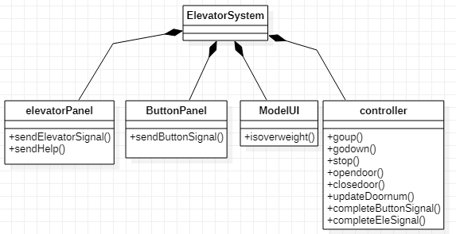

Doors, buttons and displays inside elevator is in Elevator Panel, including button ‘1’ ‘2’ ‘3’ which represent three floors to go to; button ‘open’ and ‘close’ which controls the door; button ‘help’ to call for help; display 0 or 1 which represents whether the door is opening; display 1 to 3 which shows which floor the elevator is on. Elevator Panel can send elevator and help signal to controller. It also receives commands from controller to open or close the door and updates the door number.

Doors, buttons and displays on each floor is in Button Panel, including button ‘up’ and ‘down’ which controls the elevator go up or go down; display 0 or 1 which represents whether the door is opening; display 1 to 3 which shows which floor the elevator is on. Button Panel can send button signal to controller and receive commands from controller to open or close the door and updates the door number.

Model UI is with a weight slider which can be adjusted when the elevator arrives on one floor. If it is overweight the Model UI sends signal to controller and controller send open door and stop commands to the elevator. Model UI is also with elevator cars which can go up and down. Elevator cars are controlled by the controller.

Controller receives signals from other component as well as sends signals and commands to them.

The user of the elevator system is called passengers. For a passenger who wants to go to another floor through the elevator system, he/she should first decide whether to go down or go up and push the corresponding button on the floor outside the elevator car.

Then he/she should wait for the arrival of the elevator car. He/she can check the display and know the location of the elevator.

After the elevator car arrives, the door is opened and the passenger should walk into the elevator car before the door closes.

After the passenger walks into the elevator car and before the door closes, he can either close the door immediately by pressing the closing door button or delay the closing time of the door by pressing the opening door button. However, only one button (usually the latest pressed button) takes effect at a time.

The passenger can choose the floor he/she wants to go to by pressing the corresponding number button. Then the elevator car moves to that floor in a few seconds.

After the elevator car arrives the floor the passenger chooses, the door opens. The passenger can finally walk out of the elevator and go to his/her destination.

Here is the sequence of events for using the elevator system to go from 1st floor to 3rd floor:



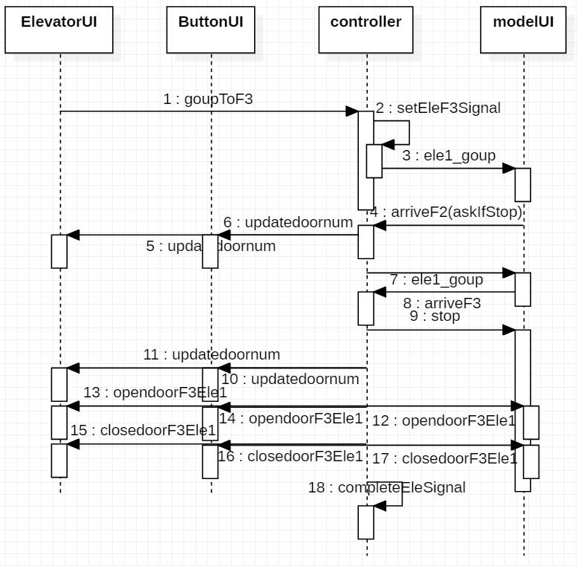

## System Architecture

From the information above, we will design an elevator system that passengers can go to arbitrary floor as their wishes. The system architecture is shown below:



## Use Cases

The system can achieve the following use cases from the passengers’ perspectives:



## Software Requirements

### R1: Elevator Panel

* R1.1: The opened door of the elevator should be able to be controlled by pressing buttons
  + R1.1.1: The opened door of the elevator should be able to delay closing when press button “open”
  + R1.1.2: The opened door of the elevator should be able to close immediately when press button “close”
* R1.2: The elevator should be able to go to the specified floor when pressing the number button inside the elevator car
  + R1.2.1: The elevator should be able to go to the first floor when press button “1”
  + R1.2.2: The elevator should be able to go to the second floor when press button “2”
  + R1.2.3: The elevator should be able to go to the third floor when press button “3”
* R1.3: The elevator should be able to stop and send out a message box when pressing the help button inside the elevator car
* R1.4: The elevator should be able to run normally after ‘help’ events are managed.
* R1.5: The display should be able to show the state of the door of the elevator
  + R1.5.1:The display should be able to show “1” when the elevator door is opening
  + R1.5.2:The display should be able to show “0” when the elevator door is closed
* R1.6: The display should be able to show the location of the elevator
  + R1.6.1: The display should be able to show “1” when the elevator is on the first floor
  + R1.6.2: The display should be able to show “2” when the elevator is on the second floor
  + R1.6.3: The display should be able to show “3” when the elevator is on the third floor
* R1.7: The door of the elevator car should be able to open
  + R1.7.1: The door of the elevator should be able to open automatically when arriving on the floor that passenger stays
  + R1.7.2: The door of the elevator should be able to open automatically when arriving on the floor that passenger goes to
* R1.8: The door of the elevator car should be able to close
  + R1.8.1: The door of the elevator should be able to close automatically several seconds after the door opens

### R2: Button Panel

* R2.1: The elevator should be able to come when press button panel on each floor
  + R2.1.1: The elevator going up should be able to come when press button “up”
  + R2.1.2: The elevator going down should be able to come when press button “down”
* R2.2: The display should be able to show the state of the door of the elevator
  + R2.2.1:The display should be able to show “1” when the elevator door is opening
  + R2.2.2:The display should be able to show “0” when the elevator door is closed
* R2.3: The display should be able to show the location of the elevator
  + R2.3.1: The display should be able to show “1” when the elevator is on the first floor
  + R2.3.2: The display should be able to show “2” when the elevator is on the second floor
  + R2.3.3: The display should be able to show “3” when the elevator is on the third floor
* R2.4: The door of the elevator car should be able to open
  + R2.4.1: The door of the elevator should be able to open automatically when arriving on the floor that passenger stays
  + R2.4.2: The door of the elevator should be able to open automatically when arriving on the floor that passenger goes to
* R2.5: The door of the elevator car should be able to close
  + R2.5.1: The door of the elevator should be able to close automatically several seconds after the door opens

### R3: Model UI

* R3.1: The elevator car should be able to move in a certain speed
  + R3.1.1: The elevator car should be able to move up in a certain speed
  + R3.1.2: The elevator car should be able to move down in a certain speed
* R3.2: The elevator car should be able to stop on a certain floor
* R3.3: The door of the elevator car should be able to open
  + R3.3.1: The door of the elevator should be able to open automatically when arriving on the floor that passenger stays
  + R3.3.2: The door of the elevator should be able to open automatically when arriving on the floor that passenger goes to
* R3.4: The door of the elevator car should be able to close
  + R3.4.1: The door of the elevator should be able to close automatically several seconds after the door opens
* R3.5: The weight slider should be able to move when the elevator arrives at each floor
  + R3.5.1: The overweight slider should be able to move up when the elevator arrives at each floor
  + R3.5.2: The overweight slider should be able to move down when the elevator arrives at each floor
* R3.6: The elevator car should stop, open the door and send a message box when it is overweight
* R3.6: The elevator car should run normally after it is not overweight

### R4: Controller

* R4.1: The controller should be able to receive signals from other components
  + R4.1.1: The controller should be able to receive signals from button panel
  + R4.1.2: The controller should be able to receive signals from elevator panel
  + R4.1.3: The controller should be able to receive signals from model UI
* R4.2: The controller should be able to send signals to other components
  + R4.2.1: The controller should be able to send signals to elevator panel
  + R4.2.2: The controller should be able to send signals to button panel
* R4.3: The controller should be able to send commands to other components
  + R4.3.1: The controller should be able to send commands to elevator panel
  + R4.3.2: The controller should be able to send commands to button panel
  + R4.3.3: The controller should be able to send commands to model UI